GitHub Submission Evidence
Screenshot 1: git status

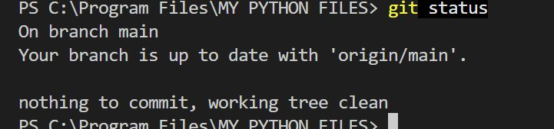

Screenshot 2: git commit

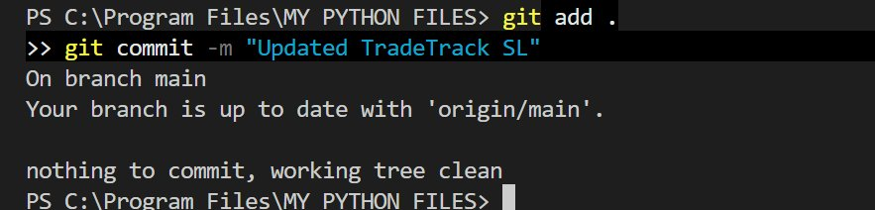

Screenshot 3: git push

